

Professor Aiden Doherty
Nuffield Department of Population Health
Big Data Institute
aiden.doherty@ndph.ox.ac.uk
01865 617794

Oxford Wearable Sensors Light, ECG, Activity and sleeP validation study
The OxSLEAP study
PARTICIPANT INFORMATION SHEET
Central University Research Ethics Committee Approval Reference: [MS IDREC 666038]

Introduction
You are being invited to take part in a research project. Before you decide it is important for you to understand why the research is being done and what it will involve. Please take time to read the following information carefully and discuss it with others if you wish. Ask us if there is anything that is not clear or if you would like more information.

Why is this research being conducted?
Wearable sensors, such as Fitbit-like devices, provide an opportunity to improve our understanding of the causes and effects of diseases. However, their accuracy is still uncertain. We invite you to participate in a study to determine how well researchers can assess sleep patterns, physical activity, and heart rate using data collected from these wearables in real-life conditions. The findings from this study could help us more accurately measure sleep and activity levels. Your data may also be used to develop new and improved sleep and activity detection methods for future research.

Why have I been invited to take part?
This study is looking for individuals who are aged 18 to 30 years. We are looking for 150 to 190 young adults to participate in this study and wear a variety of sensors across four nights and three days (Figure 1). We ask you to read this form carefully, ask any questions you might have, and then decide whether you would like to take part.
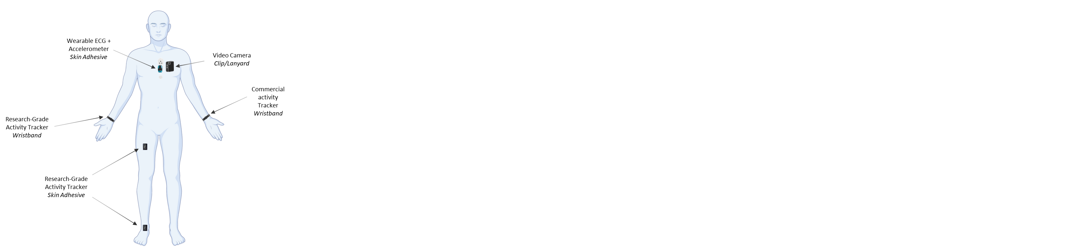
Figure 1: The various sensors that you will be asked to wear throughout the four-day, three-night monitoring period, including four activity trackers, an electrocardiogram (ECG) monitor, and a video camera.

Do I have to take part?
No, taking part in this study is entirely voluntary. You can withdraw from the study at any time, without giving a reason, even after giving consent.
If you are interested in taking part, you will have the opportunity to ask questions and discuss the study in more detail. If you agree to take part, a researcher will ask you for your consent via an online form during a call with one of the members of our research team. The study will not proceed until consent has been given.

What will happen to me if I take part in the research?
There are six main components to this study, which will take place over the course of a four-night, three-day monitoring period:
- You will undergo one at-home sleep assessment (including an electroencephalogram [EEG]) to assess your sleep quality, duration, and time spent in different stages of sleep (one night only),
- You will participate in physical activity monitoring by wearing four activity trackers on different parts of the body: 1) dominant wrist; 2) non-dominant wrist; 3) dominant thigh; and 4) dominant ankle (24 hours per day for four nights and three days),
- You will participate in sleep monitoring by placing a sleep sensor under your mattress (four nights),
- Your heart function will be monitored using a small electrocardiogram (ECG) monitor adhered to your chest (24 hours per day for four nights and three days), and
- Your activities of daily living will be logged using a first-person, forward-facing video camera worn on a neck mount around your neck or fitted to the provided chest harness (waking hours for three days).
Upon expressing interest in this study, a member of the study team will contact you to arrange a telephone call or online video call to answer any further questions you have, to ensure your eligibility for the study, to receive your consent to enrol in this study, and to arrange your participation slot. At no point will you be requested to make an in-person visit to the research offices; however, participation will require a visit by the researchers to your home to set up the devices for your at-home sleep assessment.

At-Home Sleep Assessment
At the beginning of your monitoring period, 1-2 researchers will meet you in your home during the evening hours (between 6 and 7 pm) to set up your study. You will be asked to already be wearing comfortable night clothes prior to the researchers’ arrival. This visit will take approximately 2 hours.
When the researchers arrive at your home, they will prepare you for your at-home sleep assessment, or polysomnography (PSG). PSG will include an electroencephalogram (EEG) for the duration of the night. EEG is the commonest form of measuring electrical activity of the brain (Figure 2).
Small sensors (metal discs) will be attached to your scalp, and to establish electrical contact between the scalp and the sensors, gel containing salts that conduct electricity will be applied to the scalp under each sensor. It is often necessary to prepare the area of the scalp under each sensor by cleaning it with rubbing alcohol and massaging an abrasive substance into it using a cotton swab, or scratching the surface of it with a blunt wooden stick. We would ask you to let the researcher know if at any time the procedure becomes uncomfortable. In such a case, we would stop the study procedure, without this having any negative consequences for you. The gel used to make the electrical contact is water based and washes away easily. In the morning following this first night, a researcher will again visit your home to collect this EEG equipment and assess your data. The other devices will either be collected by a courier at the end of the monitoring period, or we may ask you to return them to our team using the provided postage-paid packaging.
In the event of equipment failure, we may ask if you are willing to repeat the at-home sleep assessment on one of the following nights while continuing to wear all other devices.
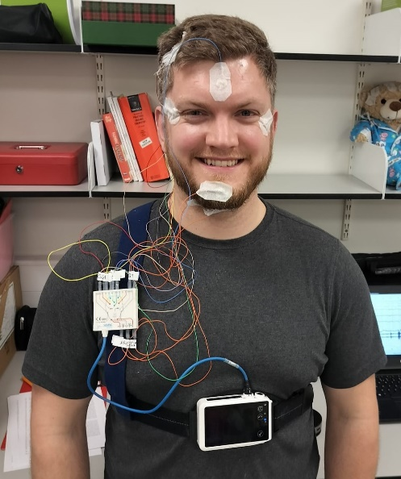
Figure 2: At-home polysomnography (PSG) for one night only
Your at-home sleep assessment will be for one night only. However, we are interested in your sleep habits throughout the monitoring period. Therefore, a researcher will help you to install a sleep sensor under your mattress (Figure 3). Once it is plugged in, you will not need to do anything with it, except to remove it after four nights. This sensor will track your sleep quantity and quality, as well as your heart rate during sleep. Additionally, every morning of the study, we will ask you to fill out a short sleep diary that will ask you questions about how much time you spent in bed and how well you slept.
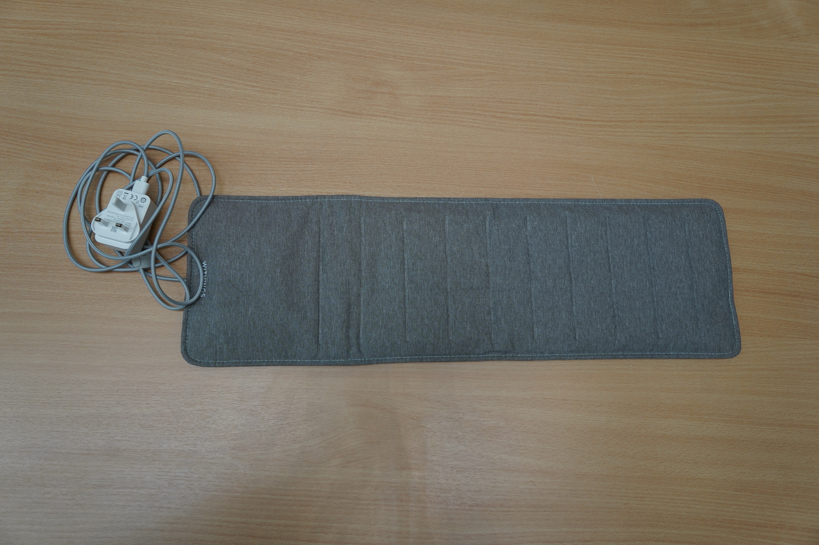
Figure 3: Under-mattress sleep sensor for four nights

Activity Trackers
When the researchers visit your home the first night, they will additionally set you up with four activity trackers on different parts of the body (dominant wrist, non-dominant wrist, dominant thigh and ankle) to monitor your sleep and physical activity (Figure 1). You will be asked to wear these waterproof activity trackers 24 hours per day for four nights and three days including when bathing or swimming. These trackers record the amount of movement you are undertaking throughout the day. They are not set up to record GPS location, cannot track your whereabouts, and do not transmit any data in real time. The devices will either be collected by a courier at the end of the monitoring period, or we may ask you to return them to our team using the provided postage-paid packaging. If you have a smartphone, we will also ask you to record the number of steps your smartphone measures each day. However, you do not need a smartphone to take part in this study.

Heart Monitoring
You will also be asked to wear an ECG monitor 24 hours per day for four nights and three days (Figure 4). This monitor will be stuck to your chest using a medical-grade adhesive. This monitor is fully waterproof and will not need to be removed during bathing or swimming (unless at a depth of greater than 3 feet). If hair is present, you will need to shave the centre area of your chest prior to monitor placement, which may take several weeks to regrow.
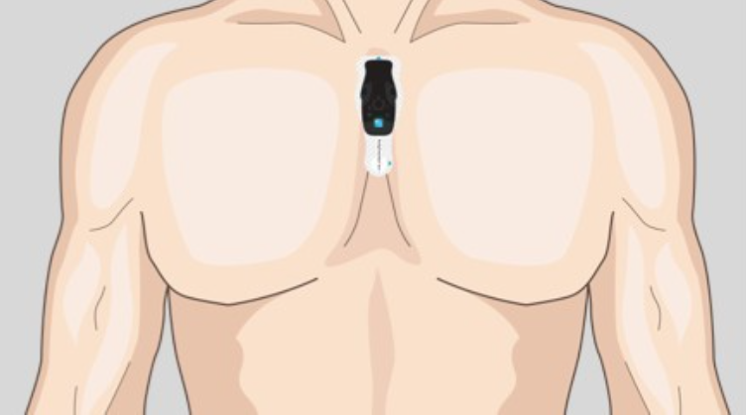
Figure 4: A similar electrocardiogram (ECG) monitor to the one you will be asked to wear 24 hours per day for four nights and three days
Video Camera
You will be asked to wear a first-person, forward-facing video camera during waking hours for three days (Figure 5). This camera will be worn on a neck mount around your neck or fitted to the provided chest harness. This camera records video and is designed to check the accuracy of your activity trackers. It does not record any audio. You will be able to remove or cover the camera at any time you would like, for example, if you would like more privacy (e.g., you are changing clothes, using the toilet, or bathing), if you are feeling uncomfortable, or if you are in a place where wearing the camera would be inappropriate (e.g., in a gym changing room). If you work with children (e.g., a teacher), we will ask you not wear the camera during working hours at school. To accommodate this, we will aim to start the study on a Thursday or Friday so that most of the recording will happen over the weekend. Data is logged and encrypted on the device, so only the research team will be able to recover the video after you have returned the camera at the end of the study. You will be able to request specific times of the day in which you would like your video recordings to be deleted in case of sensitive or private videos. For more information about the video camera and how we will protect your privacy if you decide to participate in the study, see this document here, or type in this url to the address bar: https://tinyurl.com/2w7nbkt6

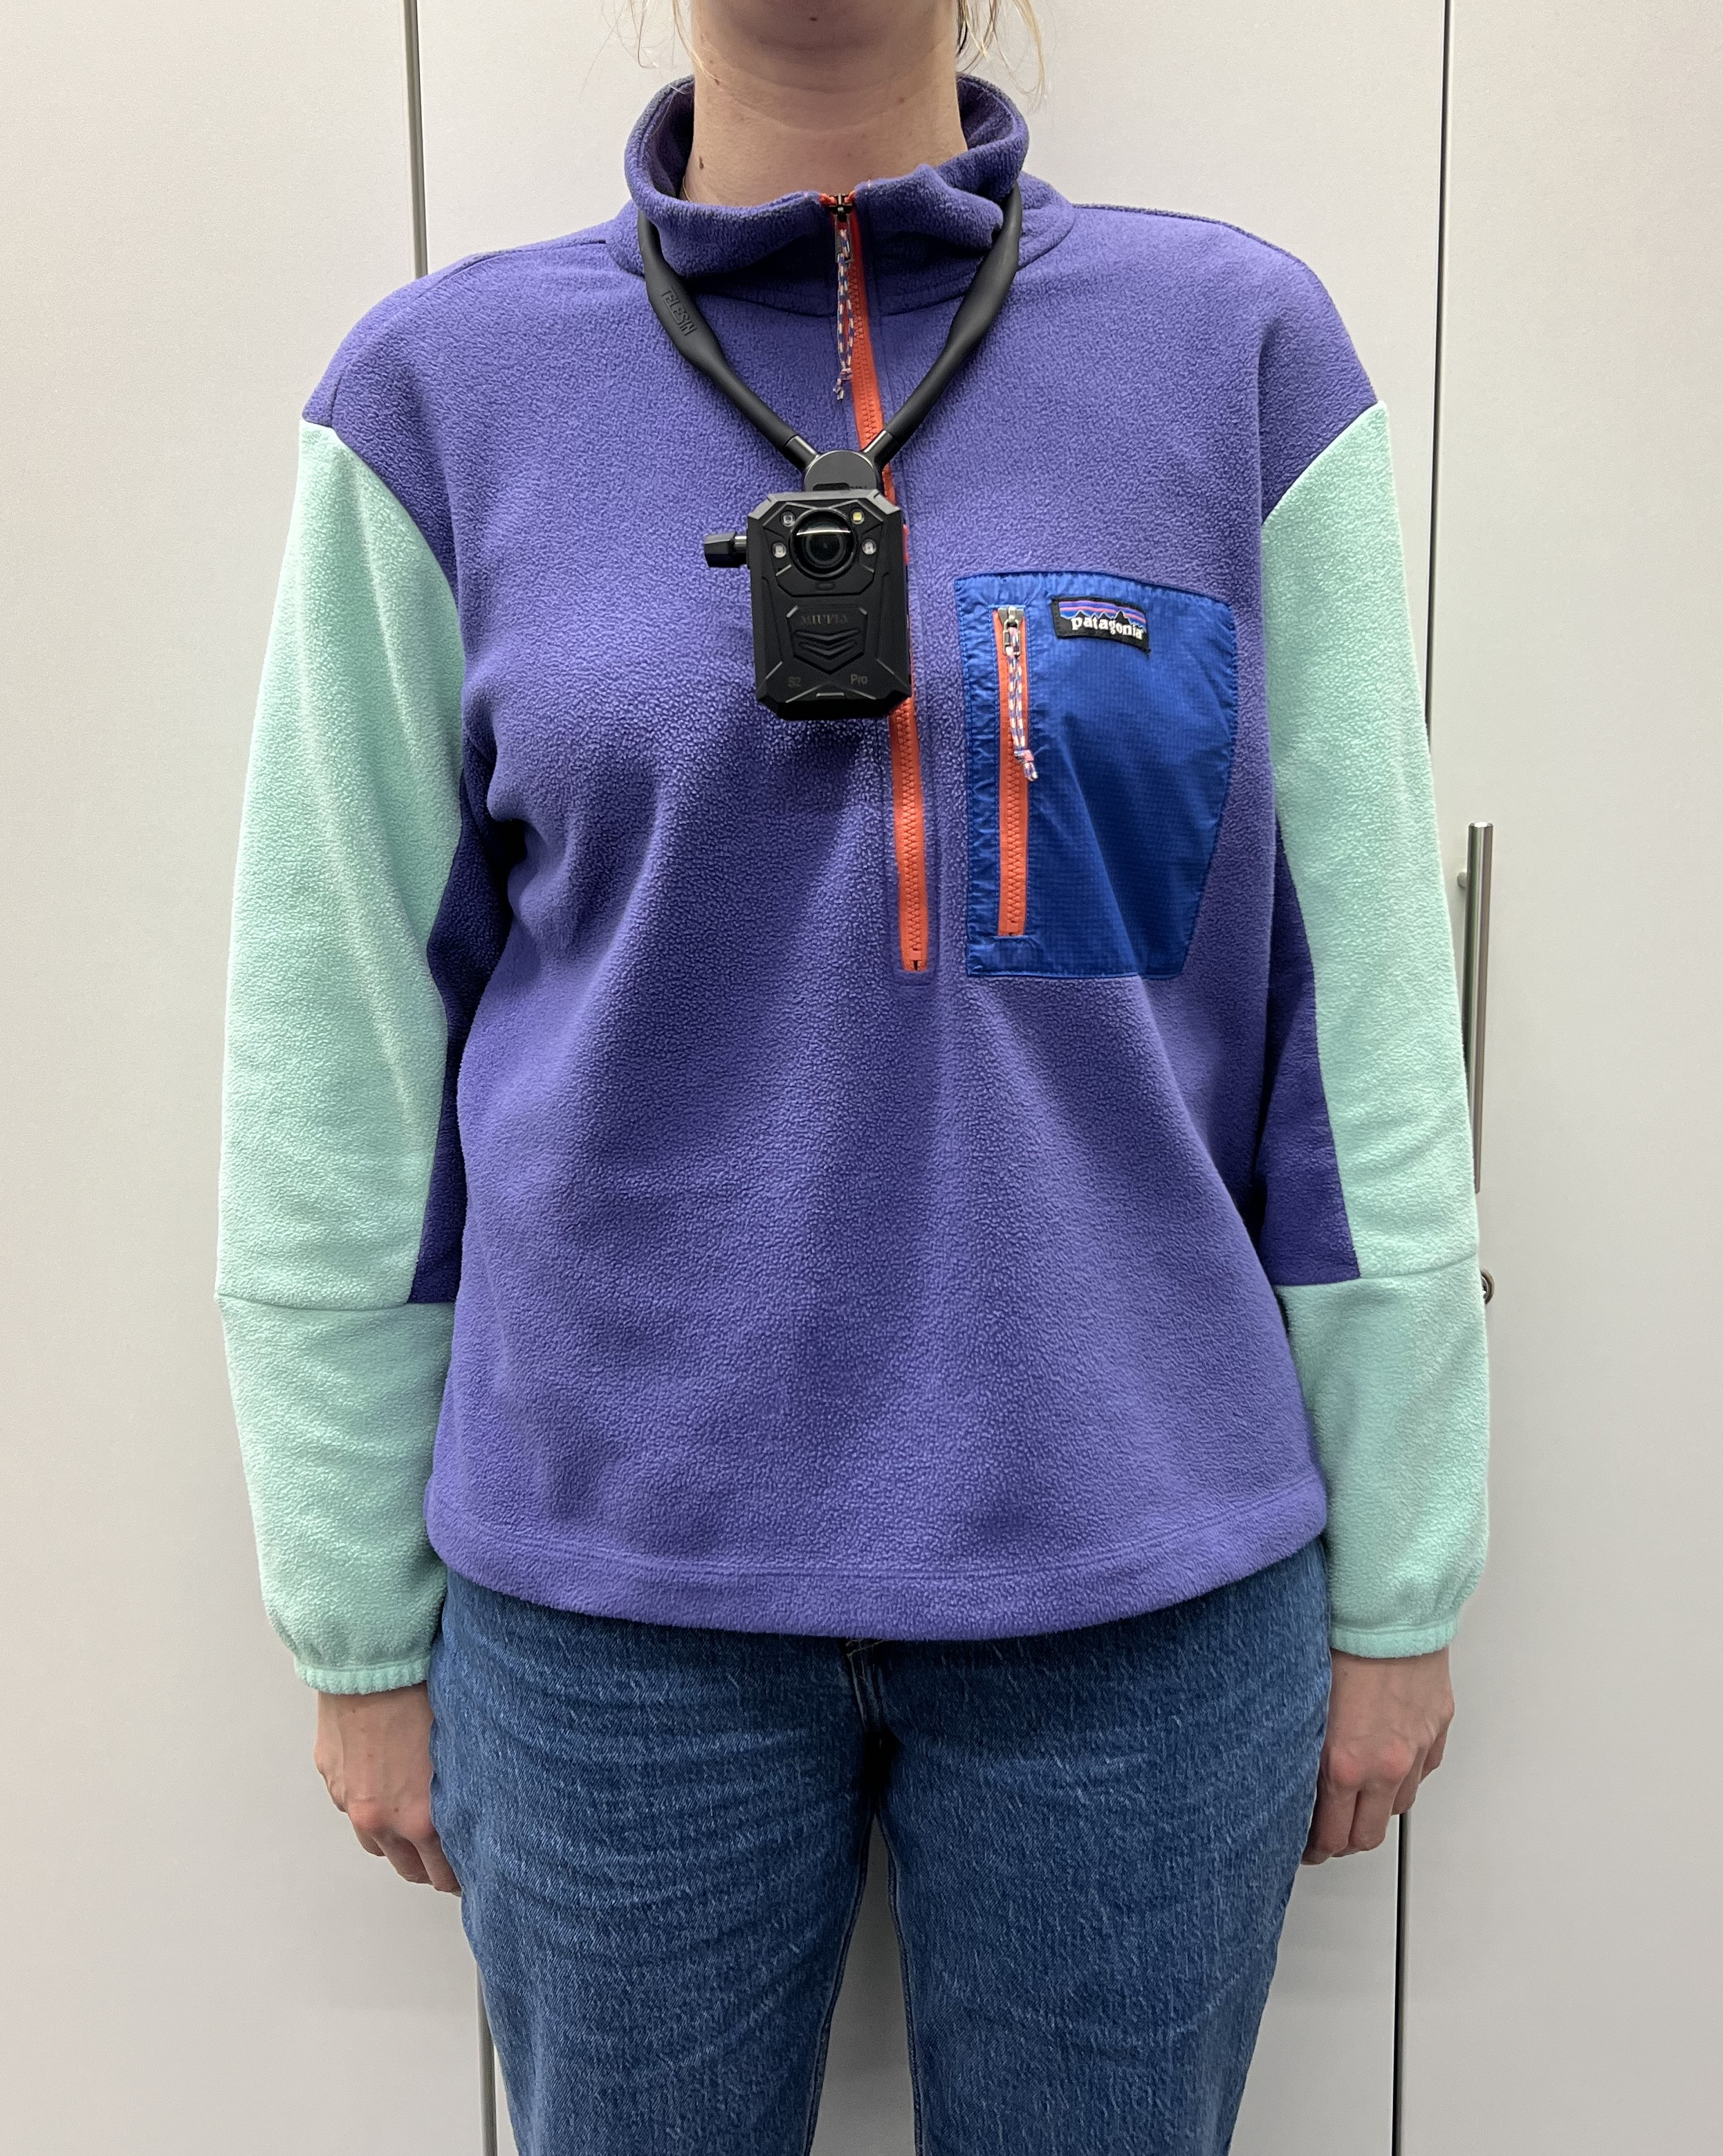
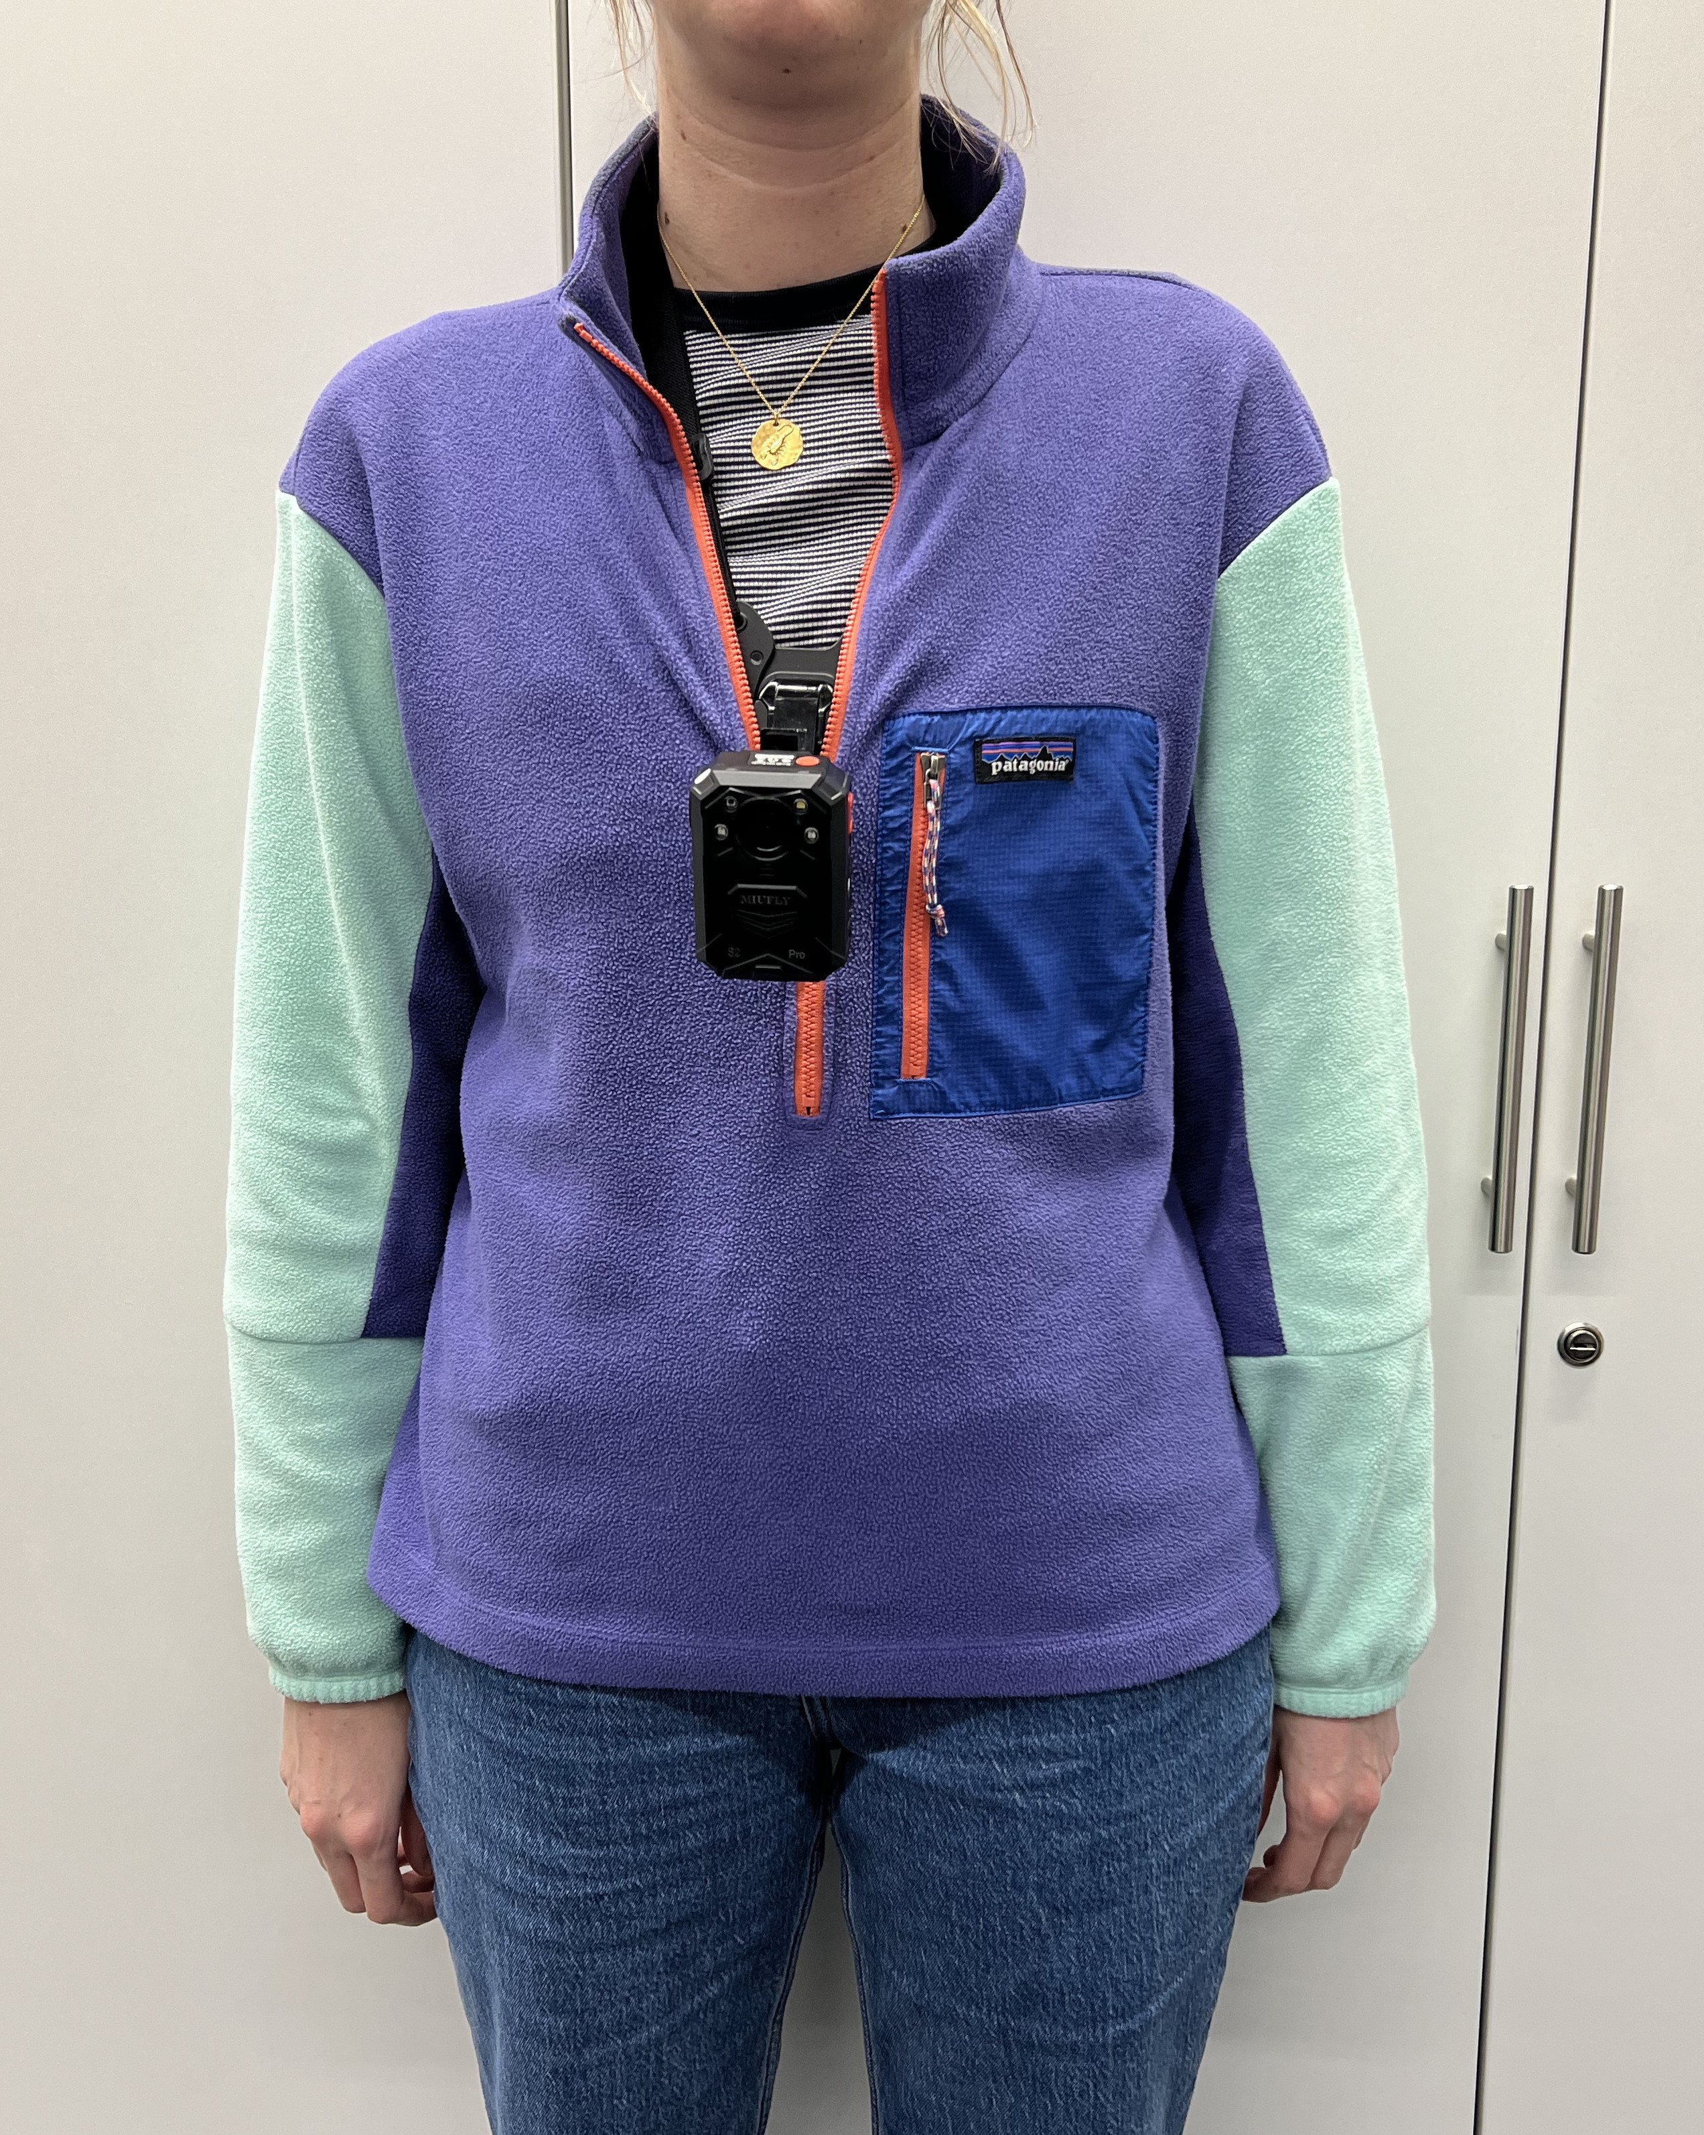
Figure 5: The first-person, forward-facing video camera you will be asked to wear during waking hours for three days.

Questionnaires
You will also be asked to complete four questionnaires about your sleep quality and mental health. You will have the option to complete the questionnaires digitally or in hard copy. You will be able to complete the questionnaires at a time that suits you rather than during the home visit for your at-home sleep assessment. It will take about 15 minutes to complete these questionnaires.

What are the possible disadvantages and risks in taking part?
The sensors for the at-home sleep assessment are commonly used in sleep research and are non-invasive and only temporarily attached to the scalp. EEG is a procedure for measuring brain waves. It is harmless and painless and carries no significant risk to participants. EEG recording has been used safely for many years and we are aware of no cases of adverse events. EEG equipment comes from certified suppliers of medical equipment, who are obliged by law to adhere to published guidelines on electrical and mechanical safety (IEC-601). If you feel any discomfort, then please let the researcher know and they will stop the procedure. Slight irritation and abrasion of your skin can occur due to the cleaning and preparation required.
There is a small risk of irritation from the medical dressing used to attach the thigh/heart/ankle monitors. If this occurs, the affected area should be cleaned and dressing replaced with a new one. If irritation continues, device should be removed.
Your GP will not be notified of your participation in this study, as your data will not be evaluated by a trained clinician. No clinical diagnoses or assessments of your health will be conducted in this study. All sleep and mental health anonymised questionnaire data will be analysed together at the end of the study, so it will not be possible to identify individual scores or for the research team to follow-up with you about any of your responses. However, if the questions trigger low emotions and/or anxiety, we advise you to contact your GP. We will also provide the contact information for United Kingdom-based mental health resources.

Are there any benefits in taking part?
You will receive a summary report about your sleep (such as sleep duration and sleep stages) and physical activity (such as steps) after you have returned all of the sensors and your data has been analysed. If you have your own device, you will be able to compare sleep and activity data from your own device to data from the sleep study (polysomnography) and our research grade devices. By taking part in this study, you are helping researchers to better understand how physical activity, sleep and other health markers can be captured using wearables sensors, as well as how these markers are associated with the risk of diseases like cardiovascular disease and dementia.

Expenses and payments
You will receive a £100 shopping voucher for participation.

What information will be collected and why is the collection of this information relevant for achieving the research objectives?
The data you provide from the various sensors and questionnaires will enable researchers to evaluate current research methods and improve future methods for the University of Oxford research community and other researchers across the world. Your age, gender, height, and weight are factors that may affect the accuracy of wearable sensors, so we collect that information to create new research methods that will be accurate for a wide range of individuals.
Identifiable data in paper form (consent forms) will be stored in a locked cabinet with limited access at the University of Oxford the Big Data Institute on for three years after publication. Electronic copies of data (consent forms, questionnaire data, diaries, contact details) will be kept on a limited access and password protected university network drive. At the onset of the study, you will be assigned a unique ID, which will be used to label your research data. The key linking your name to your activity data will be kept in an encrypted document on a University of Oxford secure server and deleted within one year of the study data collection finishing.
The information that you provide through all sensors and questionnaires will be considered research data and will be kept separate from the personal data that we collect during study registration. Image files from the automated camera will be analysed manually and through automated processes to classify activities of daily living. Research data (with the exception of camera images) will be anonymised and kept on a secure, password-protected University of Oxford storage server indefinitely. Camera images will not be able to be anonymised, but will only be accessible by the research team. As the image data is of central importance to the research data, this data will be retained indefinitely. The researcher and authorised members of the research team will have access to the research data.
We would like to use this data in future studies, and to share this with other researchers (e.g., in online databases). This means that we will make raw sensor data from PSG, under-mattress sleep sensor, activity trackers, light sensor and ECG monitor and questionnaire data publicly available for use by others. To protect your identity, we will remove potentially identifiable aspects of the data prior to sharing, including your exact age, exact height, or exact weight. Instead, this information will be summarised in ranges (for example, age: 50-54, height: 165-175 cm, weight: 65-75 kg, body mass index: 25-30). Additionally, we will randomly alter the date and time records of all data collected by sensors so that no one will be able to retrace the true time and date that any sensor was worn.
Professor Aiden Doherty will be the custodian of all personal and research data, including consent forms and participant demographics, with personal data only available to members of the research team. Each member of the research team is obligated to maintain your confidentiality as a research study participant.
Further information about your rights with respect to your personal data is available at https://compliance.web.ox.ac.uk/individual-rights. At any time, you can update your personal information or find out more about how we use your information by contacting aiden.doherty@ndph.ox.ac.uk.

Will the research be published? Could I be identified from any publications or other research outputs?
The findings from the research may be written up in a thesis, dissertation, academic publications, conference presentations, a report commissioned by an external organisation and/or websites, videos, etc. As described above, deidentified sensor data will be made available for use by other global researchers for creating and validating their own research methods. All research data will remain anonymous and participants will not be identified.
Your participation in this study is strictly confidential and your identity will remain separate from the recorded sensor data. Once your data is collected and anonymised, it will not be possible for you to withdraw your data from the study. Video camera images will contain identifiable information and cannot be anonymized, thus will only ever be seen by members of the research team and never shared externally.
Responsible members of the University of Oxford may be given access to data for monitoring and/or audit of the study to ensure that the research is complying with applicable regulations.
Please be aware that we take confidentiality very seriously and will only disclose information if there is evidence of wrongdoing or potential harm. In such cases, the University of Oxford may be required to inform the appropriate authorities.

Data Protection
The University of Oxford is the data controller with respect to your personal data, and as such will determine how your personal data is used in the research. The University will process your personal data for the purpose of the research outlined above. Research is a task that is performed in the public interest. Further information about your rights with respect to your personal data is available from the University’s Information Compliance website at https://compliance.admin.ox.ac.uk/individual-rights.

Who is funding the research?
This study is funded by the charitable research fund, The Wellcome Trust.

Who has reviewed this research?
This research has received ethics approval from a subcommittee of the University of Oxford Central University Research Ethics Committee. (Ethics reference: MS IDREC 666038).

Who do I contact if I have a concern about the research or I wish to complain?
If you have a concern about any aspect of this research, please contact Professor Aiden Doherty (aiden.doherty@ndph.ox.ac.uk) and the members of the research team, and we will do our best to answer your query. We will acknowledge your concern within 10 working days and give you an indication of how it will be dealt with. If you remain unhappy or wish to make a formal complaint, please contact the University of Oxford Research Governance, Ethics & Assurance (RGEA) team at rgea.complaints@admin.ox.ac.uk or on +44 (0)1865 616480.

Further Information and Contact Details
If you would like to discuss the research with someone beforehand (or if you have questions afterwards), please contact:
Professor Aiden Doherty
Nuffield Department of Population Health
Big Data Institute
Old Road Campus, OX3 7LF
University tel: 01865 617794
University email: aiden.doherty@ndph.ox.ac.uk

OxSLEAP
PARTICIPANT REPLY FORM
If you would like to participate in this research, please complete this reply form with your contact details and return it to the research team. Alternatively, please contact the research team by telephone 07553 476558 or email oxsleap@ndph.ox.ac.uk who will take these details from you.

Title: (e.g., Mr/Miss/Mrs/Ms/Dr) ________
First name: ___________________________________
Last name: ___________________________________
Telephone number: ___________________________
Email address: ___________________________

I have read the information sheet and would like to take part in the study.

Preferred method of contact: Phone Email

Please indicate the best time to contact you:
Morning (9am-12pm) Afternoon (12-5pm) Evening (5-7pm)

Signed: _______________________________ Date: ____________________

OxSLEAP Research Team
Tel: 07553 476558
E: oxsleap@ndph.ox.ac.uk

